How to Read Fiction:
As you interpret a story, make sure you follow the steps (to ensure your understanding)

STEP 1: SHOW NO FEAR
- YOU ARE A BOSS

STEP 2: READ THE TITLE AND STOP
- What is the title:____________________
- Based on the title, what do I think the topic/subject is:_____________________

STEP 3: READ THE STORY ALL THE WAY THROUGH
- What is the conflict (main problem of the story)?___________________________
- When is this conflict resolved?
___________________________
STEP 4: USE A DICTIONARY TO LOOK UP WORDS I
DON’T KNOW
Term | Definition

STEP 5: ANNOTATE
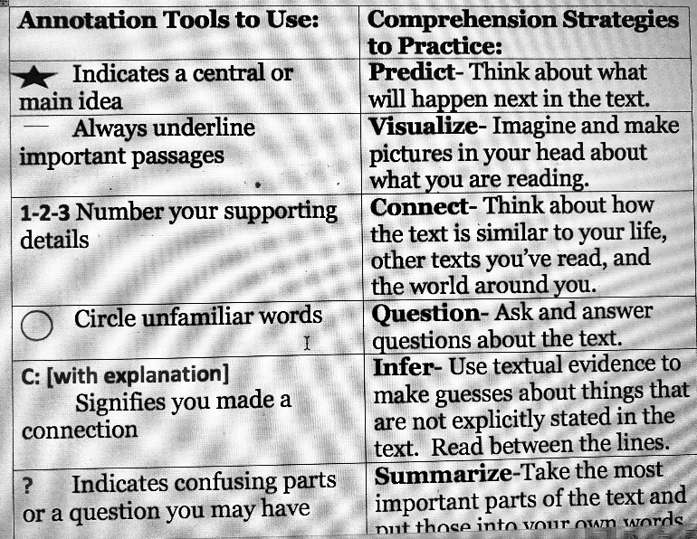

- Read through the story again and mark stars, circles, and ? marks, for your annotation tools! This is also called a “codebook.” We are coding the article for interesting details.
- What do you predict will happen to the characters next?____________________
__________________________________
- What line makes you visualize (see, hear, smell, feel) something?_______________
__________________________________
ANNOTATIONS CONTINUED….
- Connections! Does this text remind you of an event or news story? Have you read something relating to the topic? What event/news story/novel was it? Describe the connection: _________________________________
_________________________________
- Questions: What do you wonder about? What questions do you have about the characters?__________________________________________________________
__________________________________
- Inference (educated guess): Why did characters say or do certain things? What motivated each character?
____________________________________________________________________
- Summarize: What was the central (big) idea of the whole article? Who, what, when, where, why. __________________________________
__________________________________

STEP 6: IDENTIFY THE AUTHOR
- Author(s) name:____________________
- Point of View the story was written in: __________________________________

STEP 7: CIRCLE KEY SENTENCES THAT SUGGEST A THEME
- What is the theme of the story?
____________________________
STEP 8: SUMMARIZE TEXT STRUCTURE
- EXPOSITION:_______________________
- RISING ACTION:_____________________
- CLIMAX:___________________________
- FALLING ACTION:___________________
- RESOLUTION:______________________
STEP 9: READ IT ONE LAST TIME
- Which characters changed throughout the story? How does this support the theme?___________________________
__________________________________

