How to Read Nonfiction:
As we interpret our article, essay, biography, autobiography, or memoir, make sure you follow the steps (to ensure your understanding)

STEP 1: SHOW NO FEAR
- YOU ARE A BOSS

STEP 2: READ THE TITLE AND STOP
- What is the title:____________________
- Based on the title, what do I think the topic/subject is:_____________________

STEP 3: READ THE ARTICLE ALL THE WAY THROUGH
- The introduction usually gives the central idea. What is it?_____________________
__________________________________
- What are the sections titled?__________
____________________________________________________________________

STEP 4: USE A DICTIONARY TO LOOK UP WORDS I
DON’T KNOW
Term | Definition

STEP 5: ANNOTATE
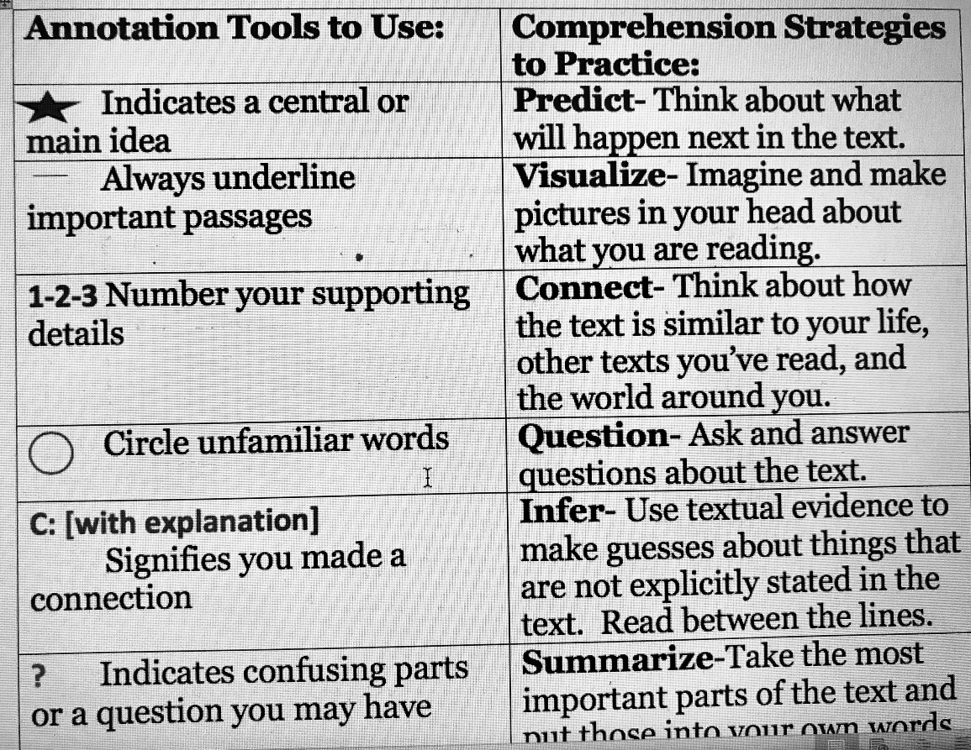

- Read through the article again and mark stars, circles, and ? marks, for your annotation tools! This is also called a “codebook.” We are coding the article for interesting details.
- What do you predict will happen next (after the stopping point)?____________
__________________________________
- What line makes you visualize (see, hear, smell, feel) something?_______________
__________________________________
ANNOTATIONS CONTINUED….
- Connections! Does this text remind you of an event or news story? Have you read something relating to the topic? What event/news story/novel was it? Describe the connection: _________________________________
_________________________________
- Questions: What do you wonder about? Do you trust the author? Why? __________________________________
__________________________________
- Inference (educated guess): Why was this article written? What motivated the people within it?
____________________________________________________________________
- Summarize: What was the central (big) idea of the whole article? Who, what, when, where, why. __________________________________
__________________________________

STEP 6: IDENTIFY THE AUTHOR
- Author(s) name:____________________
- Point of View (belief/claim):___________
__________________________________

STEP 7: CIRCLE KEY WORDS (WORDS THAT SIGNAL A NEW IDEA).
- LIST TWO POSSIBLE KEY WORDS
-
-
STEP 8: USE THE KEY WORDS TO DETERMINE TEXT STRUCTURE (COMPARE/CONTRAST, CHRONOLOGICAL, PROBLEM SOLUTION, CAUSE/EFFECT)
- What is the structure?_______________
STEP 9: READ IT ONE LAST TIME
- What is the central idea?_____________
__________________________________

