Narrative Writing Practice
Name:
Class Period:

PART 1: Narrative Writing Quiz:
- What point of view are all narratives told from?_________________________________________
- What is figurative language?___________________________________________
- What are different types of figurative language?____________________________________________
- What are sensory details?______________________________________________________________
- What are the different parts of a plot? Define each part on the diagram below.
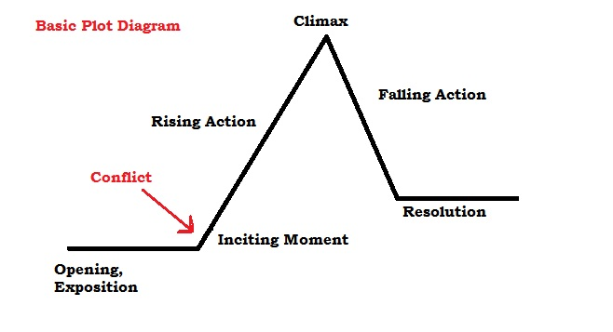
This Photo by Unknown Author is licensed under CC BY-SA

Part 2: Conflict is the central problem of a story. Match each problem with the correct literary conflict.

- Maxwell struggles with his insecurity and academic achievement.

Circle the type of conflict:
- Character vs. Character
- Character vs. Nature
- Character vs. Self
- Character vs. Society

- Kevin struggles against his illness.

Circle the type of conflict:
- Character vs. Character
- Character vs. Nature
- Character vs. Self
- Character vs. Society

- Snowball and Napoleon cannot get along.

Circle the type of conflict:
- Character vs. Character
- Character vs. Nature
- Character vs. Self
- Character vs. Society

- The animals all revolt and drive Mr. Jones off the farm!

Circle the type of conflict:
- Character vs. Character
- Character vs. Nature
- Character vs. Self
- Character vs. Society

PART 3: ANNOTATING THE WRITING PROMPT

INSTRUCTIONS: CIRCLE ALL THE VERBS IN THIS PROMPT. THEN UNDERLINE WHAT FOLLOWS THE VERBS. CREATE THE “DO WHAT” DIAGRAM TO BREAK DOWN YOUR WRITING TASK

PROMPT:

Create a personal narrative about a time you lost something, you laughed so hard, you were proud of yourself, you went on vacation, you thought you were right, or you were brave (choose one). Write your narrative in the correct point-of-view. Include figurative language, sensory details, and a clear plot structure in your writing.

Do: What:

PART 4: Brainstorm your plot with the following diagram.

This Photo by Unknown Author is licensed under CC BY-SA
PART 5: DRAFTING
____________________________________________________________________________________________________________________________________________________________________________________________________________________________________________________________________________________________________________________________________________________________________________________________________________________________________________________________________________________________________________________________________________________________
____________________________________________________________________________________________________________________________________________________________________________________________________________________________________________________________________________________________________________________________________________________________________________________________________________________________________________________________________________________________________________________________________________________________
____________________________________________________________________________________________________________________________________________________________________________________________________________________________________________________________________________________________________________________________________________________________________________________________________________________________________________________________________________________________________________________________________________________________
____________________________________________________________________________________________________________________________________________________________________________________________________________________________________________________________________________________________________________________________________________________________________________________________________________________________________________________________________________________________________________________________________________________________
____________________________________________________________________________________________________________________________________________________________________________________________________________________________________________________________________________________________________________________________________________________________________________________________________________________________________________________________________________________________________________________________________________________________
____________________________________________________________________________________________________________________________________________________________________________________________________________________________________________________________________________________________________________________________________________________________________________________________________________________________________________________________________________________________________________________________________________________________
____________________________________________________________________________________________________________________________________________________________________________________________________________________________________________________________________________________________________________________________________________________________________________________________________________________________________________________________________________________________________________________________________________________________
____________________________________________________________________________________________________________________________________________________________________________________________________________________________________________________________________________________________________________________________________________________________________________________________________________________________________________________________________________________________________________________________________________________________
____________________________________________________________________________________________________________________________________________________________________________________________________________________________________________________________________________________________________________________________________________________________________________________________________________________________________________________________________________________________________________________________________________________________
____________________________________________________________________________________________________________________________________________________________________________________________________________________________________________________________________________________________________________________________________________________________________________________________________________________________________________________________________________________________________________________________________________________________
____________________________________________________________________________________________________________________________________________________________________________________________________________________________________________________________________________________________________________________________________________________________________________________________________________________________________________________________________________________________________________________________________________________________
____________________________________________________________________________________________________________________________________________________________________________________________________________________________________________________________________________________________________________________________________________________________________________________________________________________________________________________________________________________________________________________________________________________________
____________________________________________________________________________________________________________________________________________________________________________________________________________________________________________________________________________________________________________________________________________________________________________________________________________________________________________________________________________________________________________________________________________________________
____________________________________________________________________________________________________________________________________________________________________________________________________________________________________________________________________________________________________________________________________________________________________________________________________________________________________________________________________________________________________________________________________________________________
____________________________________________________________________________________________________________________________________________________________________________________________________________________________________________________________________________________________________________________________________________________________________________________________________________________________________________________________________________________________________________________________________________________________
____________________________________________________________________________________________________________________________________________________________________________________________________________________________________________________________________________________________________________________________________________________________________________________________________________________________________________________________________________________________________________________________________________________________

PART 5: INTERVIEW WITH A PEER

- Partner up with someone at your table
- While they read you their story, diagram the plot of THEIR STORY BELOW
This Photo by Unknown Author is licensed under CC BY-SA

3. Read them your story and observe how they diagramed YOUR plot

4.Reflect on the process below:

What did you like about your partner’s story?_______________________________________________
Did your partner write in 1st person narrative voice?__________________________________________
Did your partner use figurative language, sensory details, and have a clear plot?___________________
Did your partner correctly identify your story’s conflict?_______________________________________
What could have gone better?___________________________________________________________
What should you change about your story?_________________________________________________

PART 7: Write the final draft of your story in your interactive notebook!

